School of Computing and Information Systems

COMP10001 Foundations of Computing

Final Exam Marking, 2025S1

Hours and EBA Compliance: Pay is by hours worked. If you have a PhD, claim at the “with PhD” rate. Please note the start and finish time of each marking session, and enter them correctly in your next timesheet. Marking is deemed to be “sessional” work and is not subject to the two- hour minimum engagement that applies to some other duties. However, we expect that you won’t undertake marking in blocks of less than an hour, and preferably in blocks of around two hours at a time. (Four hours in a row is permitted, but you are likely to suffer from reduced concentration by the end of such a long unbroken period and start making mistakes.)
Hours worked (and hence claimed) must be in accordance with the EBA requirements:
- Marking is an academic sessional activity and, as a result, can be worked any day of the week and is not subject to the two-hour minimum engagement requirement. However, these provisions can only be applied to the timecard if the Standard Marking rate type is selected.
- You must not more than 4.5 hours in a row without taking a 30 minute (unpaid) break, with “in a row” including all University-paid employment duties (for example, counting a work- shop as two hours of work) across all contracts/subjects/departments;
- You must not work more than 7.5 hours within a day, where “in a day” includes all University-paid employment duties (for example, counting a workshop as two hours of work) across all contracts/subjects/departments.

General Instructions:
You will be assigned one question, and will work in GradeScope to assign marks to that question. There will also be other markers also assigned to that same question, but provided you all proceed through the pool using the “Next Ungraded” button, you won’t conflict with other people.
The rubric explanations given below are summarized in to the GradeScope marking rubric, so that students will be able to see why they got the mark they did, once the results are released. So for most markers, marking consists of reading (and perhaps thinking about) their answer, selecting the appropriate button (or using the keyboard shortcuts) and then moving on.
Please don’t alter the rubric statements, or add new rubric elements. We want all students to see the same view of their mark.
The marking is anonymous. If you want any of the marks you assigned double-checked, you’ll need to note the unique identifier that is assigned and pass it on via email. One of the staff or head tutors will then also look at that answer, and make a final decision.

How to access submissions to mark in GradeScope

- From the Gradescope Dashboard, https://canvas.lms.unimelb.edu.au/courses/210521/external_tools/5945 , select the Exam: Foundations of Computing (COMP10001_2025_SM1-Long Answers Gradescope assignment.
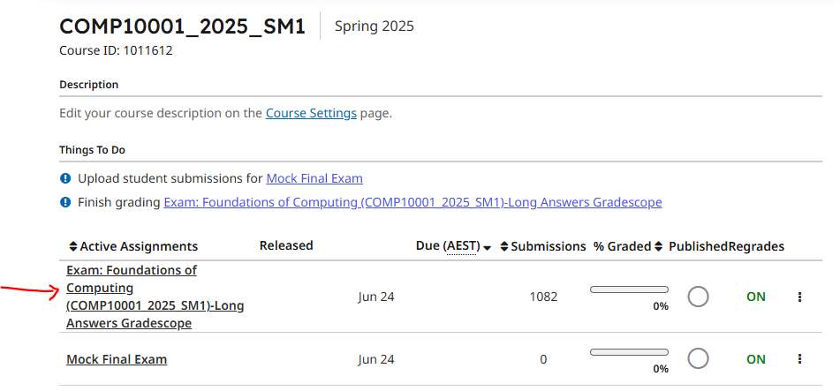
- Within the assignment, go to Grade Submissions and select a question to mark, say Q1.

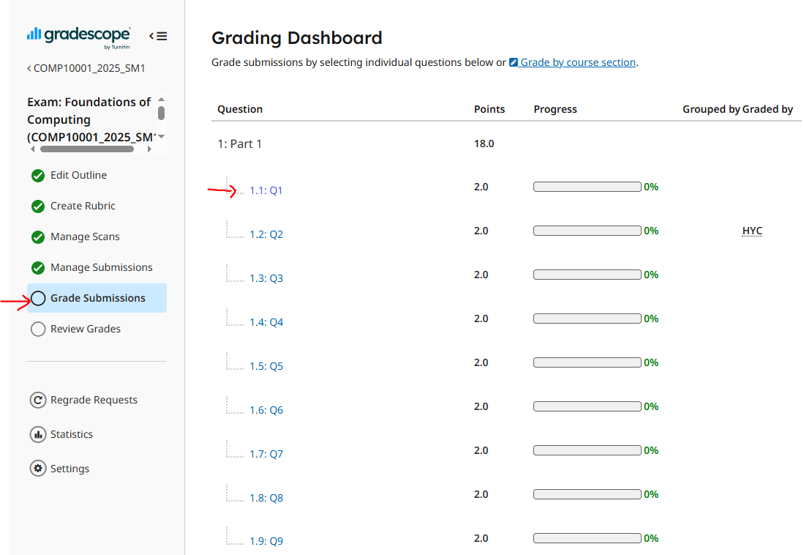

- Within the marking page, expand the rubric and mark question according to guidelines. [The list of options in the Exam is different to what is shown, you’ll see that when you get there.]

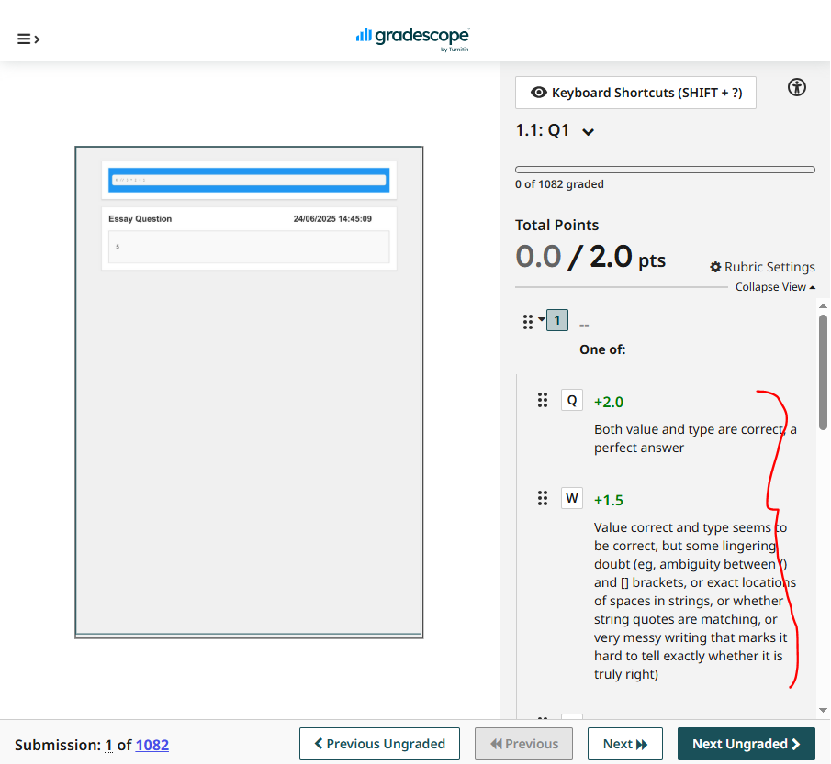

- Move on to the next student (for the same question) using the 'Next Ungraded' button at the bottom right of page.

Marking in Canvas

Accessing student submission:
Under Course Navigation, select Assignments. In the Assignment page, click the Options icon of the final exam and select the Speed Grader link.

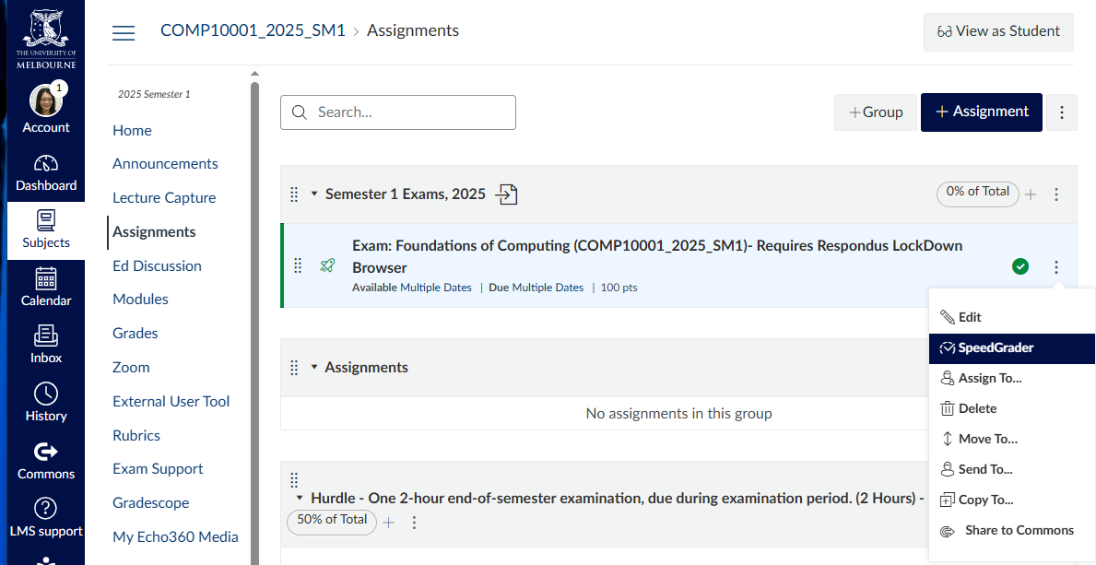

You can access the student list from the top left dropdown list.
If a student has unmarked components in their submission, it will show an orange dot next to their name.
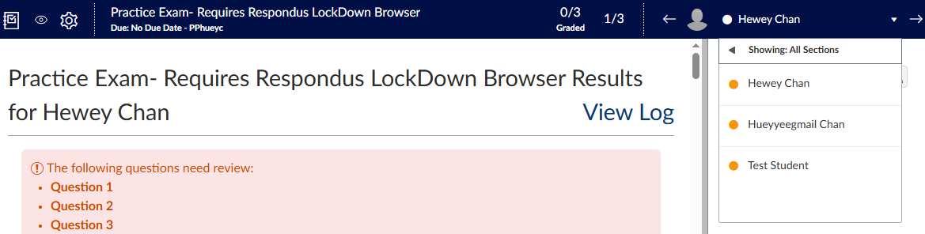
Dropdown list

Click on a student to load their submission.

Awarding a grade:
When student submission is loaded, the page will show the questions that need to be manually graded. It’s a long list! Note: The panel on the right shows the total grade that the student has obtained

Click on the question you wish to grade.
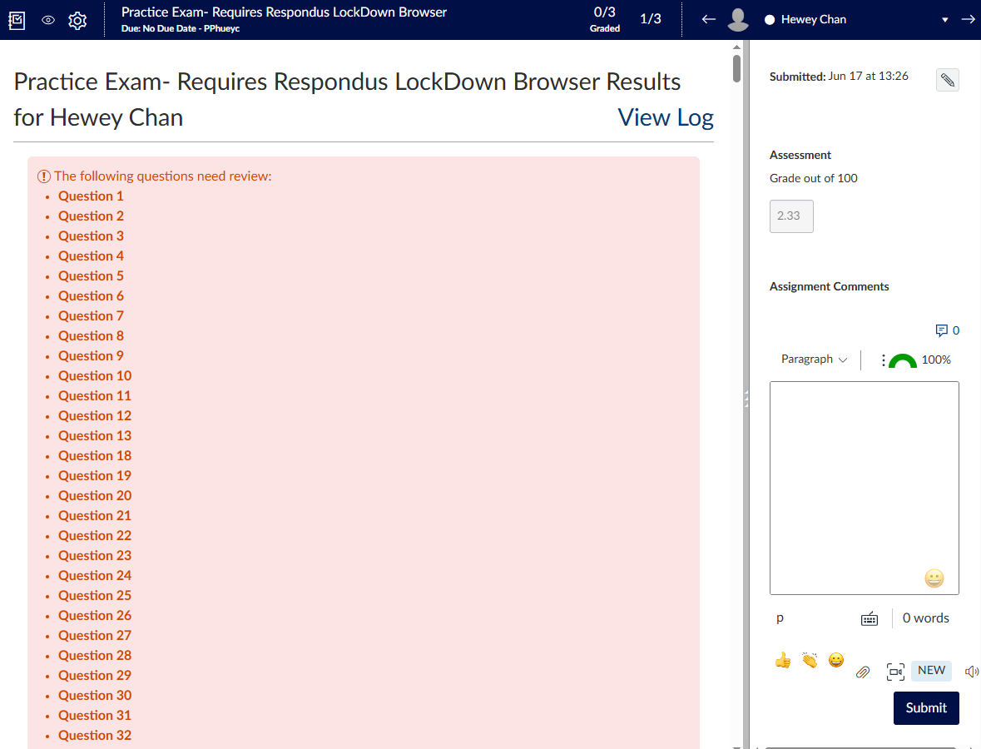
List of unmarked question
Total grade

And enter the manual grade in the points field at the top right corner of the question.
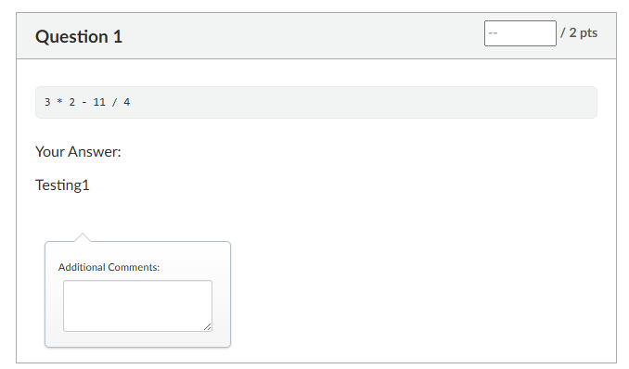
Student’s answer
Confirming grade awarded:
- Before you move on to mark a different student, REMEMBER to click the ‘Update Scores’ button at the bottom of the quiz to record the grade that you have awarded.
Check that the total grade on the right panel updates to the score that you have awarded.

- To be safe and ensure that the mark is recorded, hit the ‘Submit’ button on the right panel also.
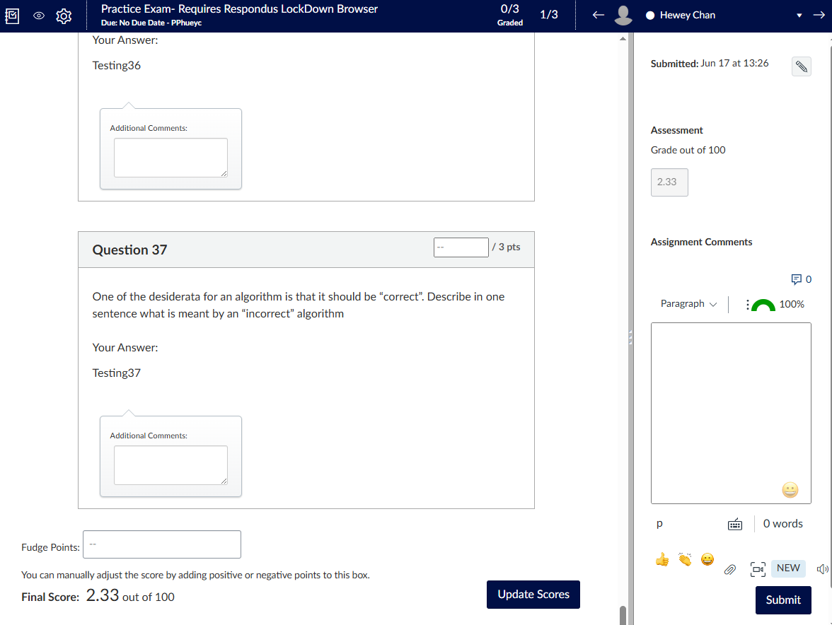
Total grade
Use the right arrow from the dropdown list at the top right of page to advance to the next student.
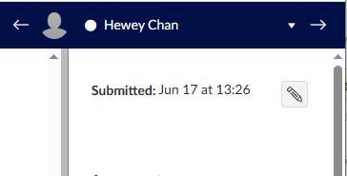

No need to include comments? Just grade will do?

Part 1 (18 marks) – Write the output of each Python expression

Each subquestion is worth 2 marks. To get full marks you must specify both the correct value and be clear in your answer that you understand what the type will be. If you think an expression is not legal according to the rules of Python, you should write Error in the box.

Q1 | 8 // 3 * 2 + 1 | 5, integer
Q2 | "Py" + "thon"[1:3] | "Pyho", string
Q3 | [10, 20, 30][1:3] | [20, 30], list
Q4 | {1, 2, 3} & {3, 4, 5} | {3}, set
Q5 | " hello world ".strip().upper() | "HELLO WORLD", string
Q6 | 3 * [1, 2] | [1, 2, 1, 2, 1, 2], list
Q7 | 5 + 4 / 2 * 3 | 11.0, float
Q8 | bin(0x10 + 0b101) | “0b10101”, string
Q9 | [x % 3 for x in range(1, 5)] | [1, 2, 0, 1], list

Each part is multiple “mark points” available, so that we can alter the category-to-marks mapping later if we wish to. So you need to look at the answer that is given, decide which of these descriptions is the best match, and then trigger that mark association using the GradeScope key mappings.
If they have explicitly added a type, for example, an answer “8 int” for part (a), then they don’t get further penalized for adding the elaboration.
Marks for each of the 9 questions:
+2.0 Both value and type are correct, a perfect answer
+1.5 Value correct and type seems to be correct, but some lingering doubt (eg, ambiguity between () and [] brackets, or exact locations of spaces in strings, or whether string quotes are matching, or very messy writing that marks it hard to tell exactly whether it is truly right)
+1.5 Value correct and major type is correct (list, set, tuple, etc), but some components/elements within that correct major type are incorrect,
+1.0 value incorrect, but (major) type correct
+1.0 value correct, but major type incorrect
+0.5 evidence of some knowledge of what computation is taking place, but neither value nor type (convincingly) correct
+0.5 multiple answers provided, one of which is (mostly) correct
+0.0 blank, or completely off track
Numbers in answers should be clearly either ints or floats. Put them in the +1.5 mark category if you think they have presented their answer carelessly in a manner that makes it hard to determine whether they want it to be an int or a float, but the value itself is correct. But if they clearly have a type wrong, they don’t get 1.5 marks, they get 1. For example, if the answer is 3.5 and they have done an integer truncated division and gotten 3, they can get +1 (right value, wrong type). And if they had 2.5, they would also get +1 (right type, wrong value). Similarly, if the answer is 3 and they have written 3.0, they get +1 (right value, wrong type).
Major types and minor types: if the answer should be [0.5, 1.0, 1.5, 2.0] and the answer given is [0.5, 1, 1.5, 2], then they have the major type correct (list) and the value correct (four correct numbers), but the minor type is not consistently given as float, and so they get +1.5 as their mark
Trailing zeros on floats are ok, provided the value is correct.
Strings should either have a pair of “” quotes or a pair of ‘’ quotes to be correct and get +2. If they have mixed them up, or if the student’s writing is sufficiently careless that you a re unsure if they are matched or not, and the answer is otherwise correct, give them +1.5.
You may use your discretion where necessary. For example, if the student has always written one answer in pencil, and then written the same answer again in ink, mark the ink one as if the pencil one is not there.

Part 2 (16 marks) – Proving a single Python assignment statement

Each subquestion is worth 4 marks. If your answer uses more than one assignment statement, you will receive 0 marks.

- Given a list values of integers, write one line of code to assign has_zero the value True if any element equals zero, otherwise False.
has_zero = any(x == 0 for x in values)
has_zero = min(map(abs, values))==0 This method fails for empty string, so should get 3

- Given a string s, assign to t the result of replacing all spaces in s with hyphens '-'.
t = s.replace(' ','-')

- Suppose that data is a Python dictionary where all values are unique and hashable. Assign to swapped a new dictionary where the original values become keys and the original keys become values.
swapped = {v:k for k,v in data.items()}

- Suppose that password is a Python string. Assign to secure_pw a new string where every vowel ('a', 'e', 'i', 'o', 'u', case-insensitive) is replaced with '*', and all other characters remain unchanged.
secure_pw = ''.join(['*' if x in 'aeiou' else x for x in password])

One or two “most obvious” ways are given here as examples, but if students have given other ways of correctly meeting the “one assignment statement” requirement they can also get 4/4.
No deductions for non-PEP8 formatting.
Marks for each of the four parts:
+4.0 One assignment statement, clear and obviously correct, using standard Python techniques,
+3.5 An answer that, after considerable thought or checking, is correct, but is substantially more complex or convoluted than is required, and takes a long-way-round to get to the required calculation (uses a sledgehammer to open a nut), involves considerable redundancy in some way
+3.0 Correct RHS expression in a single line, but incorrect or no LHS variable in assignment
+3.0 Correct LHS variable and correct RHS expression in terms of structure/calculation, but wrong variable used in RHS
+3.0 One assignment statement, and correct logical computation structure, but a single mistake that means wrong value is (perhaps only sometimes) assigned, for example, off-by-one somewhere in counting or slicing, or reversal of True/False outcomes
+2.5 Multiple assignment statements, but correct value being computed and assigned
+2.0 General intentions are in right direction, but execution contains misconceptions that are bigger than “a single mistake”; a moderate amount of further refinement necessary before it could be regarded as being “approaching correct” (doesn’t matter whether two statements or one)
+1.0 A start towards getting it right, but significant further refinement necessary before it could be regarded as being “approaching correct”; for example, mention of at least one useful component or function that would assist towards achieving the stipulated goal (doesn’t matter whether two statements or one)
+0.5 A faint glimmer of hope.
+0.0 Blank, or not even a glimmer of hope.

Part 3 (8 marks) – Multiple choice (automarked)

Q14
Q15
Q16
Q17

Part 4 (15 marks) – identify line of code

Consider the following function
def larger_than_previous(nums, query):
'''
Given a non-empty list of integers `nums` with no repetitions, and an
integer `query`, return True if query appears in nums and every integer
appearing in nums before query is smaller than query. We say that
nums[j] appears before nums[i] if j < i.
'''
# checks if query is in nums and obtains the index of query
XXXXXXXXXX # Line A
index = 0
for i in range(len(nums)):
XXXXXXXXXX # Line B
has_query = True
XXXXXXXXXX # Line C
break
# checks if every previous integer is smaller than query
is_larger_than_previous = True
XXXXXXXXXX # Line D
if nums[j] > query:
is_larger_than_previous = False
XXXXXXXXXX # Line E

Expected output:

Q18. Line A | has_query = False
Q19. Line B | if query == nums[i]:
Q20. Line C | index = i
Q21. Line D | for j in range(index):
Q22. Line E | return has_query and is_larger_than_previous

Rubric:

Three points for each question, Q18 through Q22. We do not require PEP8 spacing or layout, nor that they try and show indentation explicitly. So long as indentation is interpretable, it’s fine.
+3.0 Completely correct, including all syntactic details (for example, the : at the end in the lines where it is required).
+2.5 Correct intention, and nearly correct execution, but some syntactic issue (such as missing : at the end, or mismatched parentheses, or incorrect spelling of the correct variable name)
+1.5 Correct intention (knowing what had to happen at that point of the code), but incorrect execution of that intention, for example, in part (a) initializing to None rather than False; or being off by one in an index; or doing the right thing with the wrong variables
+0.5 Incorrect understanding of what was to happen at that point, but at least they had a go and wrote something
+0.0 Blank.

Part 5 (10 marks) - debug a Python function
Consider the following Python function:
def match_prefix(query, words):
'''
Given a possibly-empty list of strings `words`, return the list of strings in `words` that contain `query` as a prefix, case-insensitive. If there is no such string in `words`, return None instead
'''
if len(words) != 0:
prefix_list = []
for word in words:
word_prefix = word[:len(query)-1]
if query == word_prefix.lower():
prefix_list.append(word)
return prefix_list

- Trace the computation that is performed for the function call
match_prefix('app', ['application'])
to determine what is returned. Write both the return value and its type, or, if you think an exception will be raised, indicate in English what error will arise (for example, “divide by zero”, or “index out of range”, or “invalid method for type int”, and so on).
Solution: [], list
Rubric:
+1.0 Actual unambiguously correct.
+0.5 Actual seemingly correct but some sort of ambiguity is present, e.g. a "typo" or messy handwriting or partially correct

- Now write the output that should have been returned for that input if the function was working correctly. Write both the return value and its type, or, if you think an exception should be raised, indicate in English what error will arise (for example, “divide by zero”, or “index out of range”, or “invalid method for type int”, and so on).
Solution: [‘application’], list
Rubric:
+1.0 Expected unambiguously correct.
+0.5 Expected seemingly correct but some sort of ambiguity is present, e.g. a "typo" or messy handwriting or partially correct

- Next, trace the function call
match_prefix('begin', ['beginning', 'ending'])
to determine what is returned. Write both the return value and its type, or, if you think an exception will be raised, indicate in English what error will arise (for example, “divide by zero”, or “index out of range”, or “invalid method for type int”, and so on).
Solution: [], list
Rubric:
+1.0 Actual unambiguously correct.
+0.5 Actual seemingly correct but some sort of ambiguity is present, e.g. a "typo" or messy handwriting or partially correct

- Now write the output that should have been returned for that input if the function was working correctly. Write both the return value and its type, or, if you think an exception should be raised, indicate in English what error will arise (for example, “divide by zero”, or “index out of range”, or “invalid method for type int”, and so on).
Solution: [‘beginning’], list
Rubric:
+1.0 Expected unambiguously correct.
+0.5 Expected seemingly correct but some sort of ambiguity is present, e.g. a "typo" or messy handwriting or partially correct

- One error was responsible for the undesired behaviour revealed in the previous questions. Identify a minimal fix for this error, by stating the line in the code that is to change, and then providing one replacement line that corrects the error.
Solution:
Line to fix: word_prefix = word[:len(query)-1]
Fix: word_prefix = word[:len(query)]
Rubric:
+2.0 Line and replacement line both unambiguously correct.
+1.5 Line and replacement line both seemingly correct but some sort of ambiguity is present, e.g. a "typo" or partially correct.
+1.5 Missing or incorrect number but fixed line is unambiguously correct (i.e. under the assumption that the line with the actual error is being replaced).
+1.0 Correct line, partially correct fix.
+0.5 Correct line, incorrect fix.
+0.0 Blank/all aspects incorrect.

- There are two further errors present in the function that are not revealed by the previous two tests. Write a function call that would expose one of these other two errors (you may choose either).
Solution: Error 1, something like: match_prefix('App', ['app'])
Error 2, something like: match_prefix(‘1’, ['2’]) or match_prefix(‘1’, [])

Rubric:
+1.0 One of the other two errors is unambiguously revealed with the given function call.
+0.5 One of the other two errors is seemingly revealed by the given function call but some minor ambiguity is present

- Trace the function call you wrote in Question 28 to determine what is returned. Write both the return value and its type, or, if you think an exception will be raised, indicate in English what error will arise (for example, “divide by zero”, or “index out of range”, or “invalid method for type int”, and so on).
Also write the output that should have been returned for that input if the function was working correctly.
Solution: Error 1, something like: Returns [], list but should be [‘app’], list
Error 2, something like: Returns [], list but should be None, NoneType

Rubric:
+1.0 Both the actual and expected values align with the function call.
+0.5 One of the actual or expected values is correct, and the other incorrect

- Identify a minimal fix for this error, by stating the line in the code that is to change, and then providing one replacement line that corrects the error.
Solution:
For Error 1:
Line to fix if query == word_prefix.lower()
Fix: if query.lower() == word_prefix.lower()

Error 2:
Line to fix return prefix_list
Fix: return prefix_list if prefix_list else None
Rubric:
+1 A single line and replacement line is given that fixes the error.
+0.5 The correct line is identified, and the fix is partially correct.

- Now briefly describe the other error in the function in one sentence. You do not need to specify how to correct it.
Solution:
Error 1: Doesn’t accommodate capital letters in prefix
Error 2: Doesn’t return None if no match (or returns [] instead of None if no match)

Rubric:
+1 The final error (not previously specified in the student's responses) is clearly identified and unambiguously described in one sentence.
+0.75 The final error (not previously specified in the student's responses) is identified but the answer has a minor ambiguity or is unnecessarily long winded.
+0.5 The final error (not previously specified in the student's responses) is seemingly identified but the answer is somewhat ambiguous.
+0.25 A number of ambiguities are present, and parts of the response may be missing, but the answer is suggestive of identification of one of the remaining errors.
+0.0 Blank/all aspects incorrect

Part 6 (22 marks) - Python functions
These sub-questions required writing a simple function, worth 6 marks for part (a) and 8 marks for each of the two remaining parts (22 marks total). One possible solution to each part is given below. Other solutions are possible too, of course.

Recall the Textoggle game from Assignment 1. Each square on the board could either have an uppercase English letter, or a 'blank' character. Like in Scrabble, blanks could be used to represent any character. The Textoggle board was represented as a list of lists of characters. The 'blank' character is represented as an underscore ('_'). For example, one Textoggle board could look like this:
board = [['X', 'A', 'E', 'H'],
['I', 'S', 'R', 'T'],
['C', 'K', 'E', '_'],
['M', 'U', 'O', 'S']]
In this part, you will write a number of functions to process Textoggle boards. You may write other supporting functions if you wish, but are not required to. For each of these questions, you may assume the board is at least 2 x 2, and does not contain any blank tiles.
Note that you will not be able to use the Tab key in the questions below. You should indicate indentation by using four space characters in place of a Tab. You are also encouraged to use the Preformatted font for consistent character spacing.

General marking guidelines for Part 6:
- Students were told they could use Python standard library functions provided there were corresponding import statements written down. No other libraries are allowed.
- No comments are required, and magic numbers/strings should not be penalised.
- Input validation is not required but doesn’t have to be penalised either if it doesn’t affect the behaviour of the function in an unreasonable manner.
- The fact that the students were working outside of a code editor means that we shouldn’t be picky about layout and spacing within lines (PEP8-level detail), but if there is a clear violation of indenting that would lead to incorrect execution, their answer needs to be penalized.
- The marking is “holistic”, and you should examine their code and make a value judgment about where their function fits into the following spectrum.
- Marking with at least one other person on the same question part is a good way to ensure consistency, especially if the part is being marked for the first time. You’ll find there are some common approaches and mistakes that are made.
- Also feel free to add notes/example responses under each respective part below to assist others who might end up marking the same question later. If you have a question, feel free to comment in this doc or ask in Slack.

- Write a Python function
similarity(board, char)
that takes two parameters: board, a list of lists representing a Textoggle board, and char, a single-character string representing a character on the board.
Your function should return a non-negative integer representing the number of times that char appears on the board.
Here are two possible execution sequences:
>>> similarity([['A', 'B', 'C'], ['B', 'B', 'C'], ['A', 'A', 'A']], 'B')
3
>>> similarity([['A', 'B', 'C'], ['C', 'D', 'A'], ['A', 'A', 'A']], 'E')
0
Solution:
def similarity(board, char):
return sum([1 for row in board for _ in row])
Rubric:

+6.0 Fully correct function with a nested loop over board. Counts number of matching characters.

+5.0 Correct logic but minor issues, such as unnecessary checks or minor syntax errors that don’t impact functionality

+4.0 Mostly correct logic but contains unnecessary complexity or redundant checks. OR, one “silly” logic error such as:
+3.0 Partial correctness. The function updates some characters' defeated status but misses edge cases or contains significant inefficiencies. OR, one or two “big” logic errors

+2.0 General attempt with relevant syntax and partial logic, but contains substantial errors in the logic. OR, many logic errors or contain “structural issue”

+1.0 Minimal attempt that shows some understanding, such as defining the function or initializing variables but lacks functional code. OR, no loop involved or hard-coded solution.

+0.0 No attempt or completely incorrect code.

- Write a Python function
most_common_letter(board)
that takes one parameter: board, a list of lists representing a Textoggle board. Your function should return the character that occurs most frequently on the board. In the event of a tie, the character that occurs first alphabetically should be returned. For example, 'A' should be returned instead of 'B' if both 'A' and 'B' occur the same number of times on the board.
Here are two possible execution sequences
>>> most_common_letter([['A', 'B', 'C'], ['D', 'E', 'F'], ['A', 'B', 'B']])
'B'
>>> most_common_letter([['A', 'B', 'C'], ['A', 'B', 'C'], ['A', 'B', 'C']])
'A'

Solution:
from collections import defaultdict
def most_common_letter(board):
count = defaultdict(int)
for row in board:
for char in row:
count[char] += 1
counts_list = [(-v,k) for k,v in count.items()]
counts_list.sort()
return counts_list[0][1]

Rubric:

+8.0: Fully correct function that counts the occurrences of each character and returns the most frequent. The alphabetically first is favoured in ties.

+7.0: simple syntax errors, ambiguous handwriting or unnecessary calculations

+6.0: one logic error, such as:
- Not handling ties correctly
- Sorting in the wrong direction

+5.0: 2 or 3 logic errors, or multiple major syntax errors

+4.0: structural problem or many major logic errors

+2.0: a faint glimmer of hope

+0.0: no attempt or completely incorrect/irrelavant code

- Recall that in Textoggle, word can be formed on the board if each letter (other than the first) is a horizontal or vertical neighbour of the letter immediately before it in the word. Write a Python function
best_word(board, values):
that takes two parameters: board, a list of lists representing a Textoggle board, and values, a dictionary representing the point value of each letter. The keys of values are English letters, while the values are the points value associated with each letter.
Your function should return a string containing the highest value sequence of three characters that can be created on the board by following the Textoggle rules. The value of a sequence of characters is calculated by adding together the value of each character in the sequence. If there are multiple legal character sequences with the same value, any may be chosen arbitrarily.
Here are two possible execution sequences:
>>>best_word([['A', 'B', 'C'], ['A', 'B', 'C'], ['A', 'B', 'C']], {'A': 7, 'B': 1, 'C': 5})
'AAA'
>>> best_word([['A', 'B', 'B'], ['B', 'B', 'B'], ['C', 'C', 'C']], {'A': 7, 'B': 1, 'C': 5})
'CCC'

Solution:
def score(word, values):
return sum([values[char] for char in word])

def in_board(i, j, board):
return 0 <= i < len(board) and 0 <= j < len(board)

def best_word(board, values):
rows = len(board)
cols = len(board[0])
best_words = [best_word_from_index(board, i, j, values)
for i in range(rows) for j in range(cols)]
return sorted(best_words,reverse=True)[0][1]

def best_word_from_index(board, i, j, values):
directions = [(-1, -1), (-1, 0), (-1, 1),
(0, -1), (0, 1),
(1, -1), (1, 0), (1, 1)]
results = []
for di1, dj1 in directions:
i1, j1 = i + di1, j + dj1
if not in_board(i1, j1, board):
continue
for di2, dj2 in directions:
i2, j2 = i1 + di2, j1 + dj2
if not in_board(i2, j2, board):
continue
str = board[i][j] + board[i1][j1] + board[i2][j2]
results.append((score(str, values), str))
return sorted(results,reverse=True)[0]

Rubric:

+8.0: Fully correct function that calculates the points for each possible word, and sorts words by highest to lowest scores.

+7.0: simple syntax errors, ambiguous handwriting or unnecessary calculations

+6.0: one logic error, such as:
- Sorting in wrong direction
- Indexing off the board
- Calculating the scores per word wrong

+5.0: 2 or 3 logic errors, or multiple major syntax errors

+4.0: structural problem or many major logic errors

+2.0: a faint glimmer of hope

+0.0: no attempt or completely incorrect/irrelevant code

Part 7 (11 marks) – Response to short answer questions

Write a response to each of the short answer questions below.

- A company creates a new AI system designed to make it easier to hire graduates for programming roles. The system examines applicants' resumes and social media profiles and compares them to staff who have previously been successful in similar positions. The company claims their system will be completely fair in its hiring recommendations, as it uses computer algorithms and is thus free from human bias. Is this claim likely to be true? Explain your answer with the aid of an example relevant to this domain.

Solution:
No, if the past hiring practices were biased, then the future hires will be biased in the same way. As an example, an algorithm trained like this in the 1970s would essentially ensure that all hires for engineering roles were men, and all secretarial positions were women.

Even if there had been no prior bias in past hiring practices, changing demographic patterns could also cause future problems. E.g. if a firm had never hired anyone from Uzbekistan since no one had applied, they might be unfairly excluded from consideration in the future.

Rubric:
+4.0: Complete and accurate answer that correctly identifies the issues with this approach (historic bias present in the training data could be replicated into the future) and provides a relevant example illustrating the difference.

+3.0: Mostly correct answer with an explanation of potential issues, but with minor omissions in the example or explanation.

+2.0: Partially correct answer, with an attempt to explain potential issues but missing key details or providing an unclear example.

+1.0: Minimal understanding, providing a vague or inaccurate description of potential issues without an example or meaningful comparison.

+0.0: No answer or completely incorrect response.

- Examine the following code snippet:
def my_func(a):
if a == 0:
return '0'
if a ==1:
return '1'
return my_func(a-1) + my_func(a % 2)
What will be returned by the function call my_func(4)?

Solution: 1010
Rubric:
+4.0: Correct unambiguous answer.

+3.0: Same digits in different order

+2.0: One missing, incorrect, or extra digit

+1.0: Two missing, incorrect or extra digits

+0.0: No answer or completely incorrect response.

- Give an example of a problem that you may choose to use Monte Carlo Simulation to help solve. Explain what features of the problem make Monte Carlo Simulation a suitable choice, and how Monte Carlo simulation can be used to help solve the problem.

Solution 1:
Some examples include weather forecasting, prediction of sharemarket, insurance risk (1 mark). These are problems that have a high degree of randomness and/or unpredictability in the outcomes (1 mark). Random sampling is used to simulate a large number of possible instances to generate a statistical distribution of likely outcomes.
Solution 2:
Calculating the odds of poker hands. There is a clear procedure for shuffling a deck and dealing with known probabilities, so it is easy to simulate, but the maths is slightly complicated (not really but you know). Create a list of all cards, choose 5, count how many times you see each poker hand. Repeat many times, and the percentages will converge to the true odds.
Rubric:
+ 1 mark for each of the following done correctly:
- Identified a suitable example
- Identified the key feature of the problem as including randomness
- Description of how Monte Carlo simulation solves the problem includes the need for repetition over a large number of instances

Question 6a
Describe what is needed to convert an iterative solution to a recursive solution, specifically identifying the key aspects required for recursion.
Marks:
+3.0: Complete and accurate answer with clear explanation of the essential elements needed for converting an iterative solution to a recursive one. Identifies the base case and recursive case, explains how each iteration corresponds to a recursive call, and addresses the termination condition.

+2.0: Mostly correct answer, addressing the key concepts (base case and recursive case) but lacking some clarity or missing minor details (e.g., doesn’t clearly address the termination condition).

+1.0: Partially correct answer that demonstrates understanding of recursion but lacks important details or contains significant errors.

+0.5: Minimal understanding, such as a vague mention of recursion without explaining specific components like the base case or recursive step.

+0.0: No answer or completely incorrect response.

Question 6b
Explain the advantages of using iterators and provide an example scenario where iterators are beneficial.

Marks:
+3.0: Complete and accurate answer with clear explanation of the essential elements needed for converting an iterative solution to a recursive one. Identifies the base case and recursive case, explains how each iteration corresponds to a recursive call, and addresses the termination condition.

+2.0: Mostly correct answer, addressing the key concepts (base case and recursive case) but lacking some clarity or missing minor details (e.g., doesn’t clearly address the termination condition).

+1.0: Partially correct answer that demonstrates understanding of recursion but lacks important details or contains significant errors.

+0.5: Minimal understanding, such as a vague mention of recursion without explaining specific components like the base case or recursive step.

+0.0: No answer or completely incorrect response.

Question 6c
Briefly explain the concepts of divide and conquer and dynamic programming, describe how they differ, and provide an example illustrating these differences.

Marks:
+4.0: Complete and accurate answer that correctly defines both divide and conquer and dynamic programming, clearly explains the difference between the two approaches (e.g., divide and conquer divides the problem independently, while dynamic programming reuses solutions to subproblems), and provides a relevant example illustrating the difference.

+3.0: Mostly correct answer with accurate definitions of both concepts and an explanation of their differences, but with minor omissions in the example or explanation.

+2.0: Partially correct answer, with an attempt to explain both concepts but missing key details or providing an unclear example.

+1.0: Minimal understanding, providing a vague or inaccurate description of one or both concepts without an example or meaningful comparison.

+0.0: No answer or completely incorrect response.

